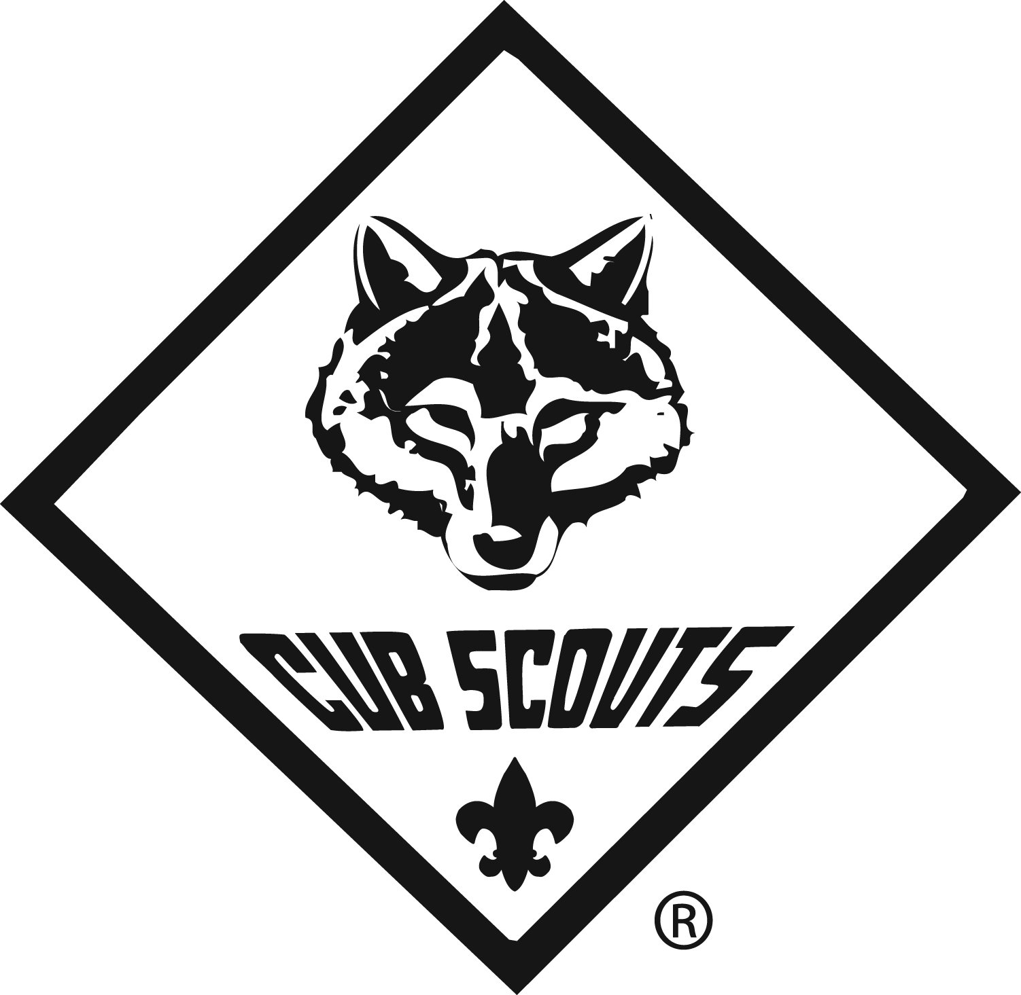
Parents!
Are you and your child looking for adventure?
Then you want to join the
Cub Scouts!

What’s in it for the Children?
Games, activities, camping, arts and crafts, leadership opportunities, community service projects, crime and drug prevention programs, fun, fun, and more fun!

What’s in it for the Parents?
An opportunity to see your child grow, build self-confidence and self-esteem and work together as a team with children of their age. Scouting helps you to create the potential for your child’s accomplishments. It gives your child a sense of teamwork and belonging.

Scouting has year-a-round enrollment.

CUB SCOUTING IS FOR CHILDREN IN KINDERGARTEN THROUGH FIFTH GRADE. YOU CAN JOIN CUB SCOUTING WITH THE FOLLOWING UNITS:

Sign-up Night for Cub Scouts in Pack 185! (Boy Dens)
Wednesday, Sept. 3, 7 pm at Penn Township Fire Department, 1750 Pine Rd, Newville, PA
Contact Assistant Cubmaster Debra Caldwell (lildeby@yahoo.com) at (717) 254-1968

Sign-up Night for Cub Scouts in Pack 174! (Boy and Girl Dens)
Tuesday, Sept. 9, 6:30 pm at Newville First Church of God, 475 Shippensburg Rd, Newville, PA
Contact Cubmaster Andrew Byers (pack174@outlook.com) at (717) 372-8538

For more information, or to find a different unit from the ones listed on the back, please contact
District Director Cory Kercher at (717) 590-5454 or cory.kercher@scouting.org

The Big Spring Area School District does not sponsor or sanction this program/event/activity
Your child DOES NOT have to be a member of the school or organization where the open house is being held. They are welcome to join the Cub Scouts at any location. To learn more about Cub Scouts, please visit us online at:
www.beAscout.org

