**How’s Your Mindset?**

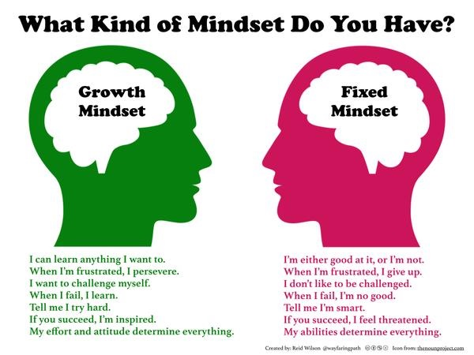

**Fixed vs. Growth**